CREATING NODE RED UI
TEAM ID | PNT2022TMID36331
PROJECT NAME | GAS LEAKAGE MONITORING AND ALERTING SYSTEM FOR INDUSTRIES

After creating the Node Red Web
Application, we have to install the UI
interface in Node Red.

➢ Copy and pasting the URL of the NodeRed in the new tab

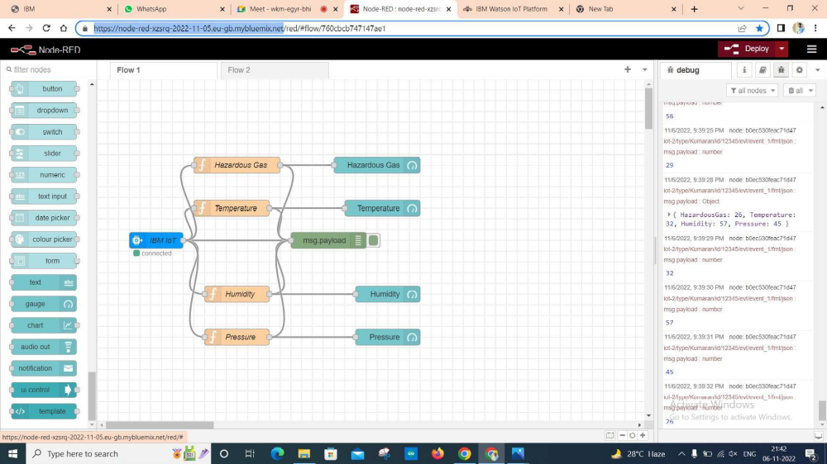
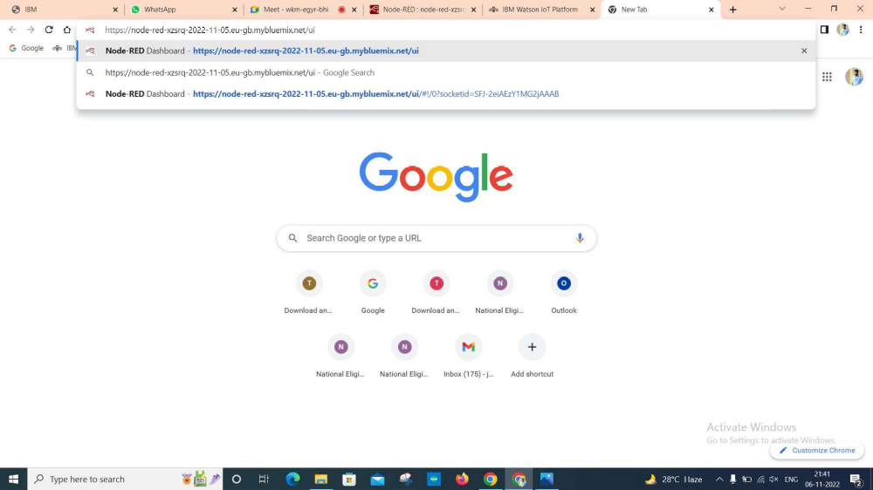
➢ Output
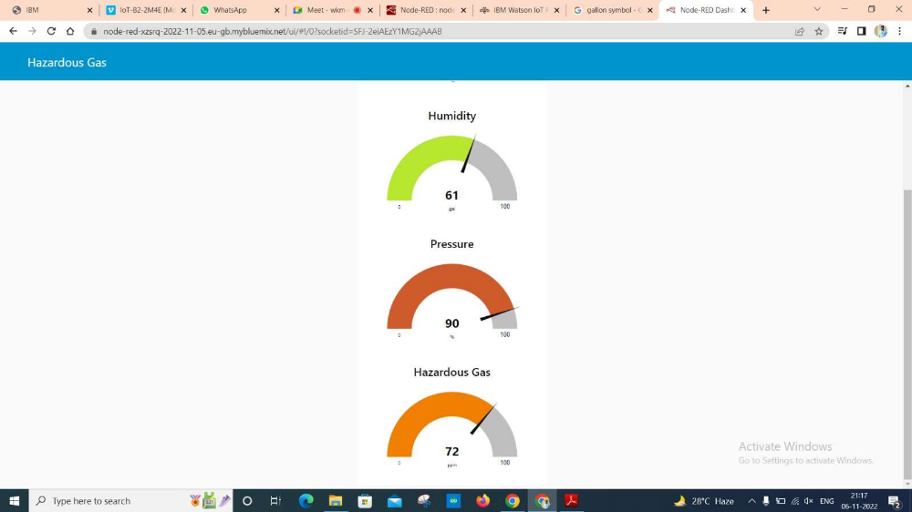

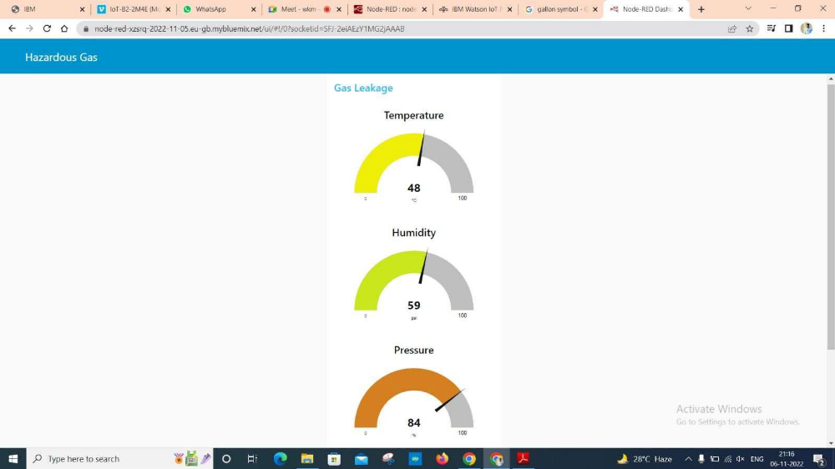
Link:https://node-red-xzsrq-2022-11-05.eu-gb.mybluemix.net/ui/#!/0?socketid=SFJ-2eiAEzY1MG2Jaaab

RESULT:

Thus, the Node Red UI is created successfully

